### **Quick-Start Guide for Zoom Participants**

Trinity College Research, Instruction, Technology Department – July 2020

## **To Join a Zoom Meeting**

Click on the link in the email invitation. You may then be prompted to download and install the Zoom app or a browser plugin. Follow the instructions, and then select if you would like to connect audio and/or video, and then click Join. You do not have to have a Zoom account to attend a Zoom meeting.

## **Mute/Unmute Audio and Adjust Audio Options**

Using audio in a Zoom meeting requires you to have access to either a microphone through your computer or a telephone. Please be aware that the host can control participant audio during the meeting. This means the host can mute and unmute you at any time. Check the icons in the menu bar and the Participants panel to determine your current audio setting.

* A close up of a sign

  Description automatically generatedTo unmute yourself and begin talking, click the **Unmute** button (microphone) in the bottom-left corner of the meeting window.
* To mute yourself, click the **Mute** button (microphone). A red slash will appear over the microphone icon indicating that your audio is now off.
* To test your computer microphone and speakers, click the **up arrow** to the right of the microphone icon and select **Audio Settings**.

NOTE: You can switch to a different audio input device using the Audio Settings option. If you have joined the meeting via computer audio, be sure to leave computer audio before dialing in to the meeting via the phone.

## **Start/Stop Video and Adjust Video options**

* Click the **Start Video** button in the menu bar at the bottom of the window to begin your video stream.
* Click the **Stop Video** button to stop sharing your video stream.
* To choose a different webcam or adjust your video settings, click the **up arrow** to the right of the Video icon and select **Video Settings**.

NOTE: When your video is activated, The **Enter/Exit Full Screen** options are available in the upper right of the screen. Your view may automatically switch to full screen during a presentation when a presenter shares their screen. To exit full screen, hit the ESC key. Use the controls in the upper right to switch between active Speaker view or Gallery view of the other participants when there is no screen sharing.

NOTE: If you choose not to turn on your webcam in the meeting and video has been activated, your video window will display either your name, email address, or a photo, depending on how your profile is set up in the Zoom Web Portal.

## **Send Messages with Chat**

You can send a chat message to all participants in the meeting or privately to specific individuals.

NOTE: When you enter a meeting, any messages posted in chat prior to you joining the meeting are not visible to you in the chat panel.

Send a Message to Everyone

* Click the **Chat** button in the menu bar to open the Chat panel.
* Type your message in the **Text box** at the bottom of the panel.
* Press **Enter** to send the message.
* 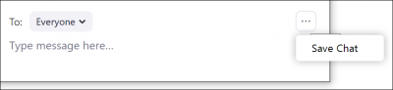To save the chat transcript, click the **More** button at the bottom of the chat panel and select **Save Chat**.
* Send a Private Message

You can send a private message to a single person by clicking the down arrow in the **To:** field and selecting the person's name from the list. The person's name will stay selected until you click the down arrow again and select **Everyone (In Meeting)**.

## **Provide Feedback with Nonverbal Feedback Icons**

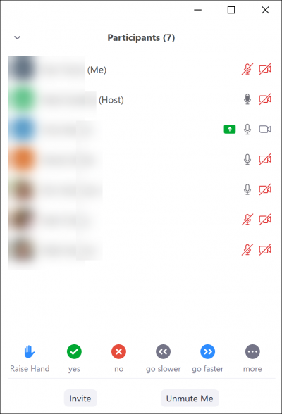Nonverbal feedback icons allow you to indicate to the host that you have a question, let the host know what you are thinking without interrupting the meeting, and respond quickly to questions or prompts from the host. Nonverbal feedback icons include options for raise hand, yes, no, thumbs up, go slower, go faster, clap, need a break and away.

* Click the **Participants** button in the menu bar to open the Participants panel.
* Click any **nonverbal feedback icon** to display the response to the right of your name in the participant panel.
* Click the **icon** again to clear it.
* Click the **…more** button to display additional icons, such as thumbs up or thumbs down.
* You can only have one icon visible at any time. After clicking an icon, clicking another icon will overwrite the first icon.

## **Leave a Meeting**

* Click the **Leave Meeting** option in the menu bar to exit the meeting.
* Click the **Leave Meeting** button in the confirmation dialog box.